Introduction

This report is produced by the Strategic Governance Unit (SGU) and aims to inform the CCMT of matters of importance with regard to Risk Management, Health & Safety, and Business Continuity. This report further provides the information necessary for the Joint Independent Audit Committee (JIAC) to fulfil its oversight function effectively. CCMT and JIAC members are welcome to review both the Force and local risk registers, or specific risk entries, by arrangement with the SGU team, who will provide suitable access to the relevant documents.

Risk Management, Health & Safety, and Business Continuity Introduction
Effective risk management and business continuity management are parts of the foundations of good governance. A sound understanding of risks and their management is essential if Thames Valley Police (TVP) is to achieve its objectives, use resources effectively, and identify and exploit new business opportunities. Such risks include risks to the interruption of business continuity. Consequently, in common with all significant public and private sector bodies, the Force has established frameworks for ensuring that areas of risk and business continuity are identified and managed appropriately across its activities.

TVP’s Risk Management approach derives from the principles and guidelines set out in ISO31000:2018 (Risk Management) and the National Decision Model. The key TVP governance documents are: Risk Management Strategy & Framework (July 2023); and Risk Management Policy (July 2023).

TVP’s Business Continuity Management approach derives from the principles and guidelines set out in ISO22301:2019 (Security and Resilience – Business Continuity Management) and the National Decision Model. The key TVP governance documents are: Business Continuity Management Strategy & Framework (July 2023); and Business Continuity Management Policy (July 2023).

The effective identification and management of health and safety related risks is vital to everyone working for TVP. In addition, there are relevant legal and regulatory obligations that the Force must comply with. The central Health & Safety function serves to help identify and assess risks, advise and support the business in implementing risk mitigations and dealing with issues that may arise from time to time, and performing assurance activities to check for compliance. Oversight of Health & Safety performance, risk management, and the Health & Safety function is exercised through the Health & Safety Governance Board.

The Risk Management, Health & Safety, and Business Continuity central functions within SGU form part of the Deputy Chief Constable’s portfolio.

Ongoing scanning by SGU, including Horizon Scanning and reviews of departmental and operational risk registers, enables the identification of strategic risks that are then assessed and scored with relevant business leads. The product of this process, including recommended actions, is presented to the CCMT Force Risk Management Group (FRMG). The FRMG considers and makes corporate decisions in relation to those risks and recommendations. Strategic risks can be either longer-term, fundamental risks of strategic importance or shorter-term, operational risks that have a very substantial impact or likelihood. In some instances, strategic risks may have crystallised and become issues. For noting, the Risk, Improvement, and Learning group (chaired by the Deputy Chief Constable) also provides an opportunity for senior management to review significant risks and issues and how they are being managed.

Risk Assessment Strategic Context

The general strategic context is much the same as reported previously in a number of respects – sustained global tensions and conflicts and the major economies gradually recovering from their recent difficulties.
The UK Labour Government, elected on 4 July 2024, has now had four months to settle down and begin to implement its chosen policies. The Prime Minister delivered a speech at an Interpol meeting on 4 November 2024, in which he mentioned that funding for border security would be doubled and people-smuggling gangs would in future be treated as terror networks. Whether the issues surrounding border control and illegal migration that have plagued the UK (and other countries) over recent years can be resolved through new initiatives remains to be seen.
The Chancellor presented her fist Autumn Budget on 30 October 2024. While a stated aim is to encourage growth, the essence of the budget is ‘tax and spend’. The Chancellor affirmed the manifesto pledge to boost visible neighbourhood policing with 13,000 more neighbourhood officers and PCSOs. These are to be paid for through policing efficiencies – there are no additional funding allocations. The Budget report states: “HM Treasury will work with the Home Office through Phase 2 of the Spending Review to drive police efficiencies and improve overall police productivity in England, ending wasteful contracts and enabling officers to spend more time on the front line tackling crime. This will form part of a wider police reform package to rebuild confidence in policing.” Total Home Office funding will increase from £20.3 billion actual in 2023/24 to £22.1 billion in 2025/26.
There will be an additional £2.3 billion investment in prison expansion over 2024/25 and 2025/26; this should reduce the pressures experienced recently to both request use of police custody capacity and release some prisoners early. Around 1,700 prisoners were released early in September and around 1,100 in October to ease prison over-crowding. TVP managed these processes effectively and no unexpected problems have been recorded. The Government has also stated that it is conducting a major review of sentencing with a focus on new forms of punishment outside of prisons.
It was concluded on 6 November 2024 that Donald Trump, representing the Republican Party, had won the US presidential election; he will be inaugurated as President in January 2025 with JD Vance being inaugurated as Vice-President. A significant change in various policies from the position pursued by Joe Biden is expected, particularly as the Republican Party has the majority of seats in both the Senate and the House of Representatives
The Russia-Ukraine conflict has continued much as before and is very unlikely to end in the defeat of either party. Ukraine relies heavily on funding, weapons and defence technology from Western powers. Russia has suffered heavy casualties and is reportedly drafting in soldiers from North Korea (possibly 10,000 or so) to replace losses. Vladimir Putin seems to be in no hurry to end the conflict, despite the obvious costs to the Russian economy. Donald Trump may well seek some sort of solution sooner or later as he has expressed a desire to limit US funding for Ukraine. The most likely scenario at this time appears to be that the conflict will end with Ukraine having to cede part of the territory occupied by Russia since 2014 and since 2022.
The Middle East situation has worsened since Hamas encroached upon Israeli territory and kidnapped Israeli citizens/residents on 7 October 2023. UN attempts to get a ceasefire and talks towards a resolution have all failed. Dogged US efforts to prevent the crisis from escalating have all come to nothing and Israel is now fighting and defending on four fronts: Hamas in Palestine; Hezbollah in Lebanon; the Houthis in Yemen; and exchanging blows with Iran. Further afield, there is polarised strength of feelings (pro- and anti-Israel) which has manifest from peaceful protests at one end to violent actions at the other end (including hit-and-run attacks on Israeli football supporters attending a football match in Amsterdam on 7 November 2024).
From a UK economic perspective, there is a relatively stable outlook, compared to the past 4 years:
- Terrorism Threat Level remains as SUBSTANTIAL, having been reduced from SEVERE on 9 February 2024.
- The latest UK inflation rate data, released on 16 October 2024, showed that CPI inflation had been 3.2% for the 12 months to October, continuing a broadly downward trend. Recent forecasts from the Office for Budget responsibility (OBR) and others project annual CPI inflation to be in the range 2.0 to 2.6% for the next 5 years. There is one caveat – the Autumn Budget calls for a substantial increase in Government borrowing, which is likely to result in higher Gilt yields and cause some inflationary pressure over the medium term.
- On 6 November 2024, the Monetary Policy Committee decided to reduce the Bank Rate by 0.25 percentage points, to 4.75%. OBR and others are forecasting the Bank Rate to fall steadily over the next 5 years to around 3.5%. This may be contrasted with the period from February 2009 to May 2022 when the Bank Rate was lower than 1%.
- Average earnings (AE): The OBR’s most recent forecasts are for nominal AE growth of 4.7% in 2024 and 3.6% in 2025 – real growth of 2.4% and 1.2% respectively for these two years. Projected annual AE nominal growth for 2026 to 2029 is slightly higher than the forecast inflation rate, thus in broad terms, AE are expected to keep pace with inflation.
- Mortgages and house prices: The OBR notes that the average effective UK residential mortgage rate continues to rise from a forecast of 3.7% in 2024 to a peak of 4.5% in 2027, and projected to remain at that level to 2029. House price increases are expected to continue steadily at around 2% to 3% per annum to 2029, held back by the effective mortgage rate level.
It would therefore appear that the substantial pressures from the UK’s cost of living crisis have now abated somewhat overall, but recovery remains a challenge generally and some sectors of society continue to suffer substantial hardship.
Public attention continues to be drawn to police misconduct. The BBC reported on 5 November 2024 that the College of Policing had stated that nearly 600 officers had been dismissed from the police service in England & Wales in the 12 months ended March 2024, up from nearly 400 the previous year. The article also noted that the NPCC has said “it is committed to getting rid of officers who are not fit to serve the public.”
Risk Heat Map

This map identifies the current strategic risks, and maps them in terms of priority based on current risk scores.

Key to risk trend: | No change to risk score | Risk score has increased | Risk score has decreased

 |  | Impact
 |  | 1  Minimum | 2  Moderate | 3  Major | 4  Critical
Likelihood | 4  Probable  (80% +) |  |  | 113  124 | 86
Likelihood | 3  Likely  (50% to 80%) |  | 116  122 | 123  69  98  97a  74  126  127 | 111  129
Likelihood | 2  Possible  (10% to 50%) |  | 114  97b  119  107 | 121  110 | 125  118
Likelihood | 1  Unlikely  (less than 10% | 115

Overview of Strategic Risks and Issues

Following comments made at previous CCMT/JIAC meetings, an attempt has been made to distinguish issues from risks within this report. A risk is something may happen (e.g. inability to meet a particular outcome, a regulatory requirement, or a performance standard) whereas an issue is something that has already happened. Risks have both an Impact score and a Likelihood score, whereas Issues just have an Impact score; the same Impact scoring basis has been applied, for consistency.
The tables below shows the direction of travel of each risk/issue score and the current risk/issue management status as considered by risk/issue owners and to be reviewed and agreed by the FRMG.
Issue | Impact Score | Trend | Issue Owner | Date raised
SI 1 – ESMCP (Emergency Services Mobile Communications Programme) | 4 |  | ACC France / ACO Waters | Feb 2023 (original Strategic Risk  Aug 2019)
SI 6 – Contact Management resources | 4 |  | ACC France | February 2024
SI 10 – Justice Gateway | 3.5 | new | T/ACC Wright | September 2024
SI 2 – Disclosure | 3 |  | T/ACC Wright | April 2023 (original Strategic Risk July 2021)
SI 5 – Court adjournments | 3 |  | T/ACC Wright | November 2023
SI 3 – Transport | 3 |  | ACC Murray | September 2023
SI 8 – Over-recording of crime | 3 | new | DCC Snuggs | September 2024
SI 7 – Student officer attrition | 3 |  | ACO Cornelius | September 2024
SI 9 – ADR sickness reporting | 2 | new | ACO Cornelius | September 2024
SI 4 – Unestablished posts | 2 |  | ACC Murray | September 2023

Risk | Previous Risk Score  (I x L) | Current Risk Score  (I x L) | Trend | Risk Owner | Date raised | Current Risk Action
SR 86 – Attrition | 14  (3.5x4) | 14  (3.5x4) |  | ACO Cornelius | Oct 2017 | TREAT
SR 113 – Adequacy of Police Support Carrier Fleet | 12  (3x4) | 12  (3x4) |  | ACC France | May 2023 | TREAT
SR 111 - Custody premises projects | 12  (4x3) | 12  (4x3) |  | DCC Snuggs | Sep 2022 | TREAT
SR 129 – RASO Intelligence capacity |  | 12  (4x3) | new | T/ACC Wright | Sep 2024 | TREAT
SR 124 – Geographical Information System functionality | 12  (3x4) | 12  (3x4) |  | ACO Lattanzio | May 2024 | TREAT
SR 74 - Recruitment | 12  (3x4) | 9  (3x3) |  | ACO Cornelius | Oct 2017 | TREAT
SR 97a – Missing | 9  (3x3) | 9  (3x3) |  | T/ACC Wright | Nov 2020 | TREAT
SR 69 - Funding | 9  (3x3) | 9  (3x3) |  | ACO Waters | Jan 2015 | TREAT
SR 98 - Custody | 9  (3x3) | 9  (3x3) |  | T/ACC Wright | Feb 2021 | TREAT
SR 123 – Psychological Sickness | 9  (3x3) | 9  (3x3) |  | ACO Cornelius | May 2024 | TREAT
SR 126 – Corporate Communications resilience |  | 9  (3x3) | new | DCC Snuggs | Jul 2024 | TREAT
SR 127 – Intelligence queues | 9  (3x3) | 9  (3x3) |  | T/ACC Wright | Sep 2024 | TREAT
SR 118 – Forensic Accreditation | 8  (4x2) | 8  (4x2) |  | T/ACC Wright | Sept 2023 | TREAT
SR 125 – Disability Compliance | 8  (4x2) | 8  (4x2) |  | ACO Cornelius | May 2024 | TREAT
SR 110 - Overwhelming Demand | 6  (3x2) | 6  (3x2) |  | DCC Snuggs | May 2022 | TREAT
SR 121 – Switching Off of the PSTN | 6  (2x3) | 6  (3x2) |  | ACO Lattanzio | Nov 2023 | TREAT
SR 116 - IPCO | 6  (2x3) | 6  (2x3) |  | ACO Lattanzio | Sept 2023 | TREAT
SR 122 – Organisational policies | 4  (2x2) | 6  (2x3) |  | DCC Snuggs | Feb 2024 | TREAT
SR 107 – Contractor tax compliance | 4  (2x2) | 4  (2x2) |  | ACO Waters/  ACO Cornelius | Feb 2022 | TREAT
SR 119 – Business Objects | 4  (2x2) | 4  (2x2) |  | DCC Snuggs | Sept 2023 | TREAT
SR 97b – Exploitation | 4  (2x2) | 4  (2x2) |  | T/ACC Wright | Nov 2020 | TREAT
SR 114 – Data Loss | 4  (2x2) | 4  (2x2) |  | ACO Lattanzio | May 2023 | TREAT
SR 115 – Data Integrity | 1  (1x1) | 1  (1x) |  | ACO Lattanzio | May 2023 | TOLERATE

Strategic Risk Summary

This report contains updates for the period 1 June – 30 September 2024, the nearest month-end to the quarterly November CCMT meeting for which most of the underlying data is available. The report reflects the statistical and narrative information available at the September month-end (or later for some of the Strategic Risks and Issues). Additional, more recent, matters requiring CCMT input have been included. All supporting documents can be made available.

Scoring of a TVP Strategic Risk or Issue is based on the 4x4 matrix (see Appendix 1), and the direction of travel and the risk scores from the last reporting period are included to provide an indication of the magnitude and direction of any change. Risks/issues have been scored with input from the nominated risk/issue owners, or risk/issue leads where this responsibility has been delegated, with input from the SGU risk lead.

The CCMT has approved the inclusion of three new Strategic Risks and four new Strategic Issues as follows:

- SR 126 – Corporate Communications ability to deliver on its strategic communications responsibilities
- SR 129 – Sufficient capacity to support RASO, Op Yeomanry, and Op Vedette
- SI 8 – Over-recording of crimes
- SI 9 – Failure to provide accurate and complete Annual Data Requirements (ADR) reports to the Home Office
- SI 10 – Justice being delayed due to insufficient capacity in the Justice Gateway

Areas to note for risks and issues
The table below provides the summary updates provided to SGU by leads/owners on strategic risks and issues covered in this report. Detailed descriptions for all risks and issues can be provided upon request.
Risk/Issue | Previous risk/issue score | Current risk/issue score | Risk Owner / Lead | Latest Status Update
SR 69 - Funding | 9  (3 x 3) | 9  (3 x 3) | ACO Waters | The budget for 2024/25 has been agreed by the PCC in January 2024 with the maximum permissible council tax uplift of £13. Since that time the actual returns from Councils re our council tax precept has left us £1.4m short of our predictions. The additional finance has been resolved for the current year but does require an additional £1m of savings in future years. In addition, the HO expected funding for an additional 71 officers only delivered funding for 31 officers. Demand pressures are trending an overspend in the current year and some will have a financial impact in the new financial year. These issues are closely monitored on a monthly basis.  The 2024/25 pay award has now been agreed for both Police and Staff. The HO will fund the 2.25% for all forces above the 2.5% budgeted. There is a negative financial impact on the force due to the allocation method of the additional funding c£0.9m. Other inflationary and supply risks remain due to the world economic position.  Future Investment Requirements & MTFP’s  Our infrastructure requires significant investment. The delivery of our Strategic Estates Strategy requires a substantial financial investment and will require significant additional borrowing and hence increased interest payments. The significant inflation we have experienced in the construction world is further exaggerated by the rapid decline in real estate prices, when we are trying to downsize our estate. Work to establish the affordability and value for money of the Strategic Estates strategy is required – with target conclusion by December 2024, which ties in with our grant announcement. By this time we need to have a clear roadmap of what we are or are not going to do/be able to afford.  Alongside this we are experiencing significant increases in the cost of vehicles and in particular the transition to an EV fleet. Although the transition from ICE (Internal Combustion Engine) to EVs will take a number of years, we need to start investing in the charging infrastructure now.  The initial draft of the MTFP 2025/26 – 2028/29 has commenced and has already identified additional saving requirements in addition to the £24m already identified, just to address inflationary issues. The focus of the Autumn statement on Efficiency savings and Value for Money, in addition to the increased national insurance charges will only place more pressure on the forces budgets. To address our priorities and the additional demands the force faces, the focus is on the reallocation of our existing resources, rather than growth. There is a direct relationship between the delivery of savings and the ability to invest in our infrastructure and our service delivery.  No dates have yet been given about when we will receive notification of our 2025/26 grant but we do know this will only be a 1 year settlement so will not provide the longer term financial certainty we require.
SR 74 - Recruitment | 12  (3 x 4) | 12  (3 x 4) | ACO Cornelius | This risk has been reviewed and restated as: There is a risk that …..the Force will be unable to meet existing and future demands if the expected establishment amongst specialist staff roles and volume recruitment staff roles is not reached or maintained, whilst demand and the complexity of policing increases.  There is no specific update for the risk at this time, but further work on these risks is scheduled and we are aware that consideration will be given to review and update the mitigating actions to a more robust position.
SR97a - Missing | 9  (3 x 3) | 9  (3 x 3) | T/ACC Wright | Significant advancements in risk assessment processes have enabled an average 30-minute response time for initial assessments within Contact Management. TIA days engage ICR teams in key priorities, including adultification and the “voice of the family” in investigations. The Missing Related Incident type streamlines cases, allowing MIST oversight where police deployment is unnecessary.  MOUs with care homes, reinforced by Philomena Protocol briefings, and collaboration with local authorities are embedding consistency in responding to missing children. Aligned with HMICFRS NCPI recommendations, these initiatives are expected to further reduce the risk score as implementation progresses.
SR97b - Exploitation | 4  (2 x 2) | 4  (2 x 2) |  | The development of a GBCSE and CSE themed TIA day continues, with the MASH, Policing Strategy Unit, and the Training and Development Department working together to produce a bespoke training package for all front line staff. The training day will follow the theme of Every Child Seen…Heard…Safe… principles, guiding officers through professional curiosity, the importance of completing through CP/Encompass templates, and the use of the various civil orders available to assist in the longer term protection of children.  TVP are working with the Children’s Society in a regional study assessing Hoteliers response/preventative work in relation to CSE. TVP MASH Exploitation Supervisors will be attending hotels across the whole of TVP to complete assessments, which will feed into the regional study. The aim being to protect vulnerable children from abuse in hotels, and assess the changes required working in an era where there is often no human interface between clients, and hotel chains.  Following on from the successful use of Roblox at the TVP open day, a tool to better protect children from exploitation whilst on line, and empower them to be able to seek help by sharing their voice, is being progressed with a thirty party company (Logischool) to widen the reach of the tool. The aspiration of producing a package that will be able for all schools to utilise is being investigated.  The TVP MASH Exploitation Team are now refining the process required when children are identified from the Early Vulnerability Indicator Tool (previously named Escalating Children Dashboard), as being at risk of Exploitation. With the Niche templates complete a trial process will need to be piloted with LCU/LPA staff, and the LAs, for roll out across the TVP region.  The 2024 Child Exploitation Problem Profile has been completed by FIH, and the findings will be reviewed and reported back into the Exploitation governance meeting chaired by C/Supt Kidman.
SR 98 - Custody | 9  (3 x 3) | 9  (3 x 3) |  | In October, Detention Officer capacity was 132 FTE establishment, with 116.65 FTE deployable. A bespoke Sergeant Resources Meeting is in place to improve resilience opportunities for the Custody Command. Op Safeguard was formally stood down in October 2024 and the NPCC has suggested that it will not be re-activated.  The final HMICFRS report of its inspection relation to TVP’s Custody arrangements will be published on 15 November. Communications are in hand, led by D/C/Supt Garside and the Command continues to work through its action plans in response to the reported findings and areas for improvement.  No proposed change to the risk scoring at this time.
SR 111 – Custody premises projects | 12  (4 x 3) | 12  (4 x 3) | DCC Snuggs | There is a major programme of investment in Custody premises to be completed over the longer term (roughly a ten-year horizon) to support the Force’s business requirements and strategy for Custody. The high level custody estate strategy includes the following key project/programme objectives:  - Upgrade of Loddon Valley Custody Suite as an essential project to provide operational resilience ahead of the closure/redevelopment of Maidenhead  - Redevelopment of the Maidenhead Custody Suite and enable new facilities  - Progressively refurbish the other Custody Suites  - Provide a single central/Oxford-based Custody Hub on the Headquarters North site.  The PFI arrangement for Abingdon Police Station which incorporates a major custody facility expires in 2030; a probable approach here will be to purchase the premises used for Abingdon Police Station, with that location playing a key part until the central HQ North Custody hub is developed and available for use.  The Trend has progressed from stable to increased but at this time it does not yet warrant a change in the risk score.
SR 113 – Adequacy of Police Support Carrier Fleet | 12  (3 x 4) | 12  (3 x 4) | ACC France | Peter Jardine (Fleet Support Manager) has confirmed by email to Ade Hall that there were 2 additional PSUs ordered at the start of the year, so there are an additional 2 in the pipeline which are not yet live. The additional 2 are currently unallocated and unsure if they’ll be allocated to a specific LPA, or under responsibility of Ops Planning. Chris Young and Andy Pearce will submit the funding bid for the quarterly TVP process in January and will be noted within the Continuous Business Improvement process in JOU (for re the additional 5 PSU carriers to get TVP to the 36 required). ACC Murray is aware of this plan and fact it will likely be staggered over next few years to get to the 36 required.
SR 116 - IPCO | 6  (2 x 3) | 6  (2 x 3) | ACO Lattanzio | A small working group has been formed under ACO Mike Lattanzio as SRO, an ICT Project Manager has been assigned to pull together a comprehensive remediation plan covering both the system upgrade activities to satisfy MOPI requirements as well as Business led requirements for covert activities as well as wider Force policy. Governance is in place with monthly review boards against plan.  IPCO visited TVP on 25 June 2024 as part of an inspection relating to CHIS/Surveillance. A follow-up IPCO inspection visit relating to Communications is expected on 23 July 2024. So far, TVP’s (and HIOWC’s and ICT’s) efforts and mitigation plans have proven robust and no immediate concerns have been raised by IPCO. Findings and areas of improvement will emerge in due course which will give us an appropriate opportunity to reassess the risk and continuing action plans.
SR 118 – Forensic Accreditation | 8  (4 x 2) | 8  (4 x 2) | T/ACC Wright | Ongoing monitoring of accreditation continues. Introduction of the Forensic Service delivery governance board starting in the next few months.  Slough CSI office granted accreditation and the visit in April for all Forensic services at HQ South was successful.
SR 122 – Organisational policies | 4  (2 x 2) | 6  (2 x 3) | DCC Snuggs | The risk score was increased in July, in the light of many EIAs found to be out-of-date. There are HMIC recommendations specific to policies and EIAs which need to be actioned by March 2025. Concern was expressed that TVP may not meet this target due to low traction and engagement. RIL meeting on 28 October 2024 was updated with the current position and discussed EIA currency and the latest view of risk. Majority of policies now have clear ownership, and a clear status (i.e. completed, in progress etc). More policies have now been updated and there is traction in areas such as ICT. Concerns raised regarding an independent review of policies following PCC statement.
SR 126 – Corporate Communications resilience | 9  (3 x 3) | 9  (3 x 3) | DCC Snuggs | There is a risk that ….. Corporate Communications will be unable to deliver on its strategic communication responsibilities and its key services to the force, the public and stakeholders, due to a lack of sufficient resilience and experience within the critical roles held by its senior management team due to 3 vacancies in the 4 critical roles at this level. This risk remains under assessment at this time.
SR 127 – Intelligence queues |  | 9  (3 x 3) | T/ACC Wright | The average number of intelligence reports received per week is nearly 2,500. The situation is considerably improved with the reports queue in October sitting at nearly 4,000 (approximately 43 days’ worth). This is due to an extensive programme of mitigating actions that have been put in place, which continue to bring about improvements in addressing the backlog. The plan is extensive and covers numerous areas including resourcing, staff development, wellbeing, intelligence inputs, processes, working practices and performance monitoring. Governance for this improvement plan is being managed through Gold and Silver groups (Ch. Supt and Supt led respectively). The processing times continue to be a challenge, albeit it is highly likely that processing times will be at an acceptable level towards the end of the year once the existing backlog has been addressed and further improvement measures implemented in terms of people and process changes. There are both technical (robotics) and human interventions in place to ensure that risk within intelligence reports is appropriately managed through a process of grading and triage.
SR 129 – RASO Intelligence capacity |  | 12  (3 x 4) | T/ACC Wright | A further or reformed bid to the quarterly investment process was planned for mid-October – some internal department savings have been identified.  Given the passage of time and other competing pressures (e.g. launch of non-contact sexual offences campaign), consideration is being given to realigning the RASO team priorities to fill some of the gap. One DC from the RASO team has already moved across to assist with Op Yeomanry full-time. Consideration is also being given to what further support and review can be given to non-contact sexual offences / Op Vedette. Such an approach would mean less time could be spent on surge resourcing / advice to custody / threshold test cases. For further discussion is in progress within PP&S regarding mitigations and contingencies.
SI 1 - ESMCP | 4 | 4 | ACC France | The National Programme and NPCC decision to pause most regional activity around ESMCP remains in place. However, progress at a national level in relation to new Lot 2 (system software and applications) and Lot 3 (4G network) procurements is approaching finalisation. Sign-off of the national contract for Lot 3 has been announced at a cost of approximately £2b. The National Programme Business Case has been agreed and a revised Plan is anticipated later this year, through the ESMCP Gold Group meeting on 10 October 2024. Chief officers will be updated at that meeting on expectations around the stepping-up of regional Teams.  The regional programme team (covering TVP, Hampshire, Surrey and Sussex) was shrunk to a Business Change Authority (20% FTE), following the termination of the Radio Surveyor’s coverage assurance contract at the end of June 2024. The Business Change Authority/Regional Lead (Paul Feazey) provides a liaison point between the four forces and OCiP.  Airwave is running well at the moment and that there is little fear of an increased risk of failure. However, the delay mean users are having to ‘make do’ with its ageing and limited functionality.
SI 3 - Transport | 2.5 | 3 | ACC Murray | The 7% pay rise has not made significant impact on recruitment/generating interests for advertised posts. As an alternative, looking to start apprentice program and focus on filling posts in this way. Current focus on getting new recruits in to fill in the vacant posts, and then review resourcing again but it will take time to get the necessary numbers employed and up to speed. Development of management team with Steph Budd to build up their skills and confidence.  The second half of 2024 has seen a somewhat improving picture in workshops, whereby some vacancies remain, but positions are being filled with the expectation that the next 6-12 months will see further improvement. The back-office however are continuing to see the loss of people in key managerial/supervisory roles imposing excessive workload demand for those remaining staff, unmanageable daily tasking and a lack of resilience. It will be 4-6 months before demand is potentially improved.  As at November 2024, there has been little movement on this issue this quarter. CTC are still down on staff in the workshops with work ongoing around a revised structure and pay to try and improve some of these issues. Back office is also still down on staff too, though this has been attributed to taking time to settle rather than specifically pay and skill set related. Training has now been put in place for several other supervisors.
SI 4 – Unestablished posts | 2 | 2 | ACC Murray | This issue was previously referred to as ‘The force has 224 more vacancies than its ability to fill’  We have created more posts within the organisation than we have establishment to fill them. Uplift in posts is required for students currently undertaking training. Task and finish group has been set up to identify what posts will be removed from the establishment. Through the T&F group, the 224 was reduced to 58 although is now standing at 100.  There has again been little movement on this issue this quarter. Discussion took place with CCMT in regards to how to establish the 24/25 APP bids where officer growth had been agreed in order to maintain current number of over established posts as opposed to increasing that number. However the decision was made to defer where the posts would come from. As noted in the previous report, principles are being established for future mid-term funding bids to ensure growth is not agreed without funding or where the posts will move from.
SI 6 – Contact Management resources | 4 | 4 | ACC France | The department remains optimistic that we should be at establishment by summer 25. However, a significant proportion of the workforce will be new and not yet operating at full capacity. The intention is to submit a paper through CCMT / COG to consider tactical options to mitigate the impact (paper currently awaiting finance update but should be ready be end of Oct 24).  Recruitment and Retention challenges in Contact Management are improving on the position of last year.  Current vacances across CMC and PCR are at –12 with two new courses in November which should close that gap into the new year.  Pipeline for recruitment remains very healthy with the number of applications rising.  At the end of September 24 there was 438.4 FET posts – current staffing at 426.81 (-11.59)  Courses:  October 24 – 1 course of 12 delegates – all places filled  November 24 – 2 courses of 12 delegates – 23 places filled  December 24 – no courses  January 25 – there will be 2 courses and these are being worked on now re filling of places / recruitment pipeline
SI 7 – Student officer attrition |  | 3 | ACO Cornelius | There is an issue in that the force is losing officers at a rate higher than the number of student officer posts, and at a rate greater than we can replace them. This further exposes the force to additional pressures related to the resulting lower levels of experience amongst its officer workforce.
SI 8 – Over-recording of crime |  | 3 | DCC Snuggs | There is an issue in that we are over-recording crime, which is leading to high volumes of crimes requiring cancellation and not being processed quickly enough, resulting in misleading performance data and low officer morale due to crimes not being cleared. In addition, without any mitigation to address the over-recording, there is also a risk that HMIC will be critical of TVP at the next inspection in late 2025.
SI 9 – ADR sickness reporting |  | 2 | ACO Cornelius | There is an issue that TVP is failing to provide an accurate Annual Data Requirements (ADR) report related to hours lost to sickness to the Home Office. This is due to ineffective reporting mechanisms for sickness across the force restricting the accuracy of recording on an hourly basis.  TVP could be reprimanded by the Home Office for failing to provide accurate and complete ADR reports, leading to reputational damage although this is deemed unlikely at this time as we are constrained by our recording systems but being as accurate as we can within this. Other forces are likely to be in the same position.  Consequences could include: inability to direct and measure our activity as effectively as we would like to drive positive action to reduce sickness; and operational plans in terms of capacity are based on inaccurate data which could lead to under-resourcing, impacting employees and the public.
SI 10 – Justice Gateway |  | 3.5 | T/ACC Wright | There is an issue in that justice will be delayed or potentially denied due to delays in the Justice Gateway system due to capacity limitations.

Risk Radar

Several risks not covered above in this report are under discussion with the Risk, Improvement & Learning Board and may appear as proposed Strategic Risks in future. Over recent months, the Corporate Governance Officers have provide inputs and insights to the Strategic Analysts to consider Future Risks (looking roughly 3 to 5 years ahead) alongside the analysis of strengths, weaknesses, threats, and opportunities as part of the FMS development Strategy process supporting the Chief Constable and his CCMT members.
As suggested in the previous report, a plausible worst-case scenario from a risk management perspective for TVP over the next 5 years (say – being the lifetime of the next Government) could be: TVP is charged with a new Uplift net increase target of 500 officers by end-2026; funding from central Government and council precepts is flat/no higher than inflation; there is substantial civil unrest and public disorder; we have to devote 20% or more custody cells for use by HM Prisons due to their capacity limits; more and more convicted persons are given shorter/no custodial sentences and in consequences, repeat offences increase substantially (the vicious circle); we are forced by prioritisation decisions to cut budgets on enabling functions (e.g. ICT, People, Finance, GH&SI) and accept higher risks…and inconsequence things such as robustness in defence against cyber threats may decrease. We will continue to develop our understanding of the new Government’s policies and plans to inform our risk outlook and scenarios.

Risk Management Function
Now that the Corporate Governance team is resourced to the agreed establishment level, SGU can plan to develop Risk Management practices and strengthen processes across the organisation. In due course, we expect to provide improved reporting and support. The Corporate Governance team continues to participate in the South East & Eastern Region Police Risk Group (SEERPRG) as well as in the National Risk Management Forum (NRMF), where Risk Management professionals share experiences and discuss general areas of common interest.
The Corporate Governance team continue to work on improvements in the risk management approach in respect of risk appetite and tolerances and the identification and management of ‘chronic’ risks. A note summarising the position reached to date, with some examples, is provided in Appendix 2.

Health & Safety - Overview of Key Health & Safety Risks and Issues
Health & Safety Risk Heat Map

This map identifies the current strategic risks, and maps them in terms of priority based on current risk scores.

Key: | No change to risk score | Risk score has increased | Risk score has decreased

 |  | Impact
 |  | 1  Minimum | 2  Moderate | 3  Major | 4  Critical
Likelihood | 4  Probable
Likelihood | 3  Likely |  |  | Fatigue Driving | Fire Safety
Likelihood | 2  Possible |  |  | First Aid  Lone Working | Lithium Batteries
Likelihood | 1  Unlikely

Overview of Strategic Risks and Issues
Following comments made at previous CCMT/JIAC meetings, an attempt has been made to distinguish issues from risks within this report. A risk is something may happen (e.g. inability to meet a particular outcome, a regulatory requirement, or a performance standard) whereas an issue is something that has already happened. Risks have both an Impact score and a Likelihood score, whereas Issues just have an Impact score; the same Impact scoring basis has been applied, for consistency.
The tables below shows the direction of travel of each risk/issue score and the current risk/issue management status as considered by risk/issue owners and to be reviewed and agreed by the FRMG.
Issue | Impact Score | Trend | Issue Owner | Date raised
High Number of Assault Injuries | 3 |  | ACC C. Bunt | May 2023
High Number of Training Injuries | 2 |  | ACO K. Kirby | May 2023
DSE Non-Compliance | 2 |  | DCC Ben Snuggs | May 2023

Risk | Previous Risk Score  (I x L) | Current Risk Score  (I x L) | Trend | Risk Owner | Date raised | Current Risk Action
Fire Safety | 12 | (4 x 3)  12 |  | DCC Ben Snuggs | Dec 2023 | TREAT
Fatigue Whilst Driving |  | (3 x 3)  9 | New | ACC Dennis Murray | Oct 2024 | TREAT
Lithium Batteries | 8 | (4 x 2)  8 |  | DCC Ben Snuggs | Dec 2023 | TREAT
First Aid & AEDs | 6 | (3 x 2)  6 |  | DCC Ben Snuggs | Feb 2024 | TREAT
Lone Working | 6 | (3 x 2)  6 |  | DCC Ben Snuggs | Apr 2024 | TREAT

Key Health & Safety Issues:
The three key issues are 1) High Number of Assault Injuries, 2) High Number of Training Injuries, 3) Display Screen Equipment (DSE) non-compliance.
- High-Number of Assault Injuries
- This issue was first raised in May 2023 and reviewed in May 2024 as part of the end-of-year Health & Safety performance analysis.
- The category “Assaults” (Violence Against Police Officers and Staff) is the current leading cause of injuries for the Force. The number of Assaults has been an upward trend which not only supports the rating of this issue but also indicates a growing risk to Police Officers and Staff from violence at work.
- Most recently, the public widespread criticism and targeting of the Police exacerbated by the Manchester Airport incident as well as the outbreaks of violence and disorderly behaviour targeted towards local community groups and the Police following the Southport events (Op Purslane) have heightened the chance of assaults on our People.
- To support the mitigation of this issue, the Health & Safety Team are consistently gathering and analysing assault data to identify key trends and themes in order to develop a better understanding of the issue. The data is presented and discussed at the Health & Safety Governance Board on a quarterly basis. Efforts are being made to link in with the Officer and Staff Safety Group and Local HSE Committee Meetings to enhance communication, implement preventative and mitigating actions, and to share organisational learning to support continual improvement.
- An associated issue has further been raised in relation to the under-reporting of assaults. Last year, only about 35.5% of the Assaults reported through NICHE were reported through the Health & Safety Incident Reporting system (Peoplesoft). This issue not only affects the Force’s ability to identify trends, implement preventative and mitigating action, and learn lessons but also represents a deviation from the 7-Point Plan (Step 5 states “The assaulted Officer/Staff or Volunteer must complete a Safety Incident Report with their Supervisor”). To address this issue, as well as to address previous JIAC Internal Audit Findings in relation to the lack of assurance on the compliance with the 7-Point Plan, the Health & Safety Team is implementing a new process where a gap analysis is conducted on a monthly basis to identify under-reporting trends and to simultaneously conduct 7-Point Plan checks for all assaults. The outcomes of the gap analysis and checks will be discussed quarterly at the Health & Safety Governance Board.
- High-Number of Training injuries:
- This issue was first raised in May 2023 and reviewed in May 2024 as part of the end-of-year Health & Safety performance analysis.
- The category “Training” is the current second leading cause of injuries for the Force.
- In 2023/2024, the Health & Safety Team was invited to observe the new PPST training where it was noted that the safety aspect is well-managed. The risk inherent to the PPST training was accepted as crucial in enabling us to protect the communities we serve but also in enabling us to protect our People by mitigating the risk of potential future serious injuries and fatalities. The continuous analysis of PPST will continue in 2024/2025.
- In November 2024, TVP have rolled out the new Public and Personal Safety Training (PPST) in line with the College of Policing National Curriculum and Approved Professional Practice. All incidents associated with the new Public and Personal Safety Training (PPST) are being regularly monitored and analysed by the Health & Safety Team and Learning & Development Team to identify key emerging trends in the types of injuries suffered but also to identify in what parts of the training (inc. specific scenarios and tactics) are the injuries more common.
- To date, there has been a total of 4864 Officers and Staff going through PPST and 68 injuries which represents about 1.39%. The “Take Down” (30.8%), the “Restraint” (19%), and the “Ground Restraint” (14.7%) have been identified as the tactics with the highest incidence of injuries. When focusing on the role, most (57%) of injuries occur when Trainees are the “Subject” (as opposed to the “Officer”). “Knees” (15%), “Ribs” (13%), “Back” (12%, and “Shoulders” (12%) are the areas of the body most affected. Although the percentage of injuries is seemingly low, the significance/consequence of the injuries are the most worrying with 8 Training-Related incidents being RIDDOR Reportable. Where possible, learnings from the incidents and potential mitigating actions are considered and implemented within the parameters imposed by the College of Policing.
- Display Screen Equipment (DSE)
- The issue has been identified last year by the Learning & Development Team.
- Under The Health and Safety (Display Screen Equipment) Regulations 1992, Employers have the duty to provide all Employees “adequate Health & Safety training in the use of any workstation” (also known as DSE training) and “a suitable and sufficient analysis of those workstations” (also known as a “DSE Assessment”). The Learning & Development Team identified some gaps with the DSE Training & Assessment process (managed through the DSEasy system) and were able to put together a list of around 3000 people who had not completed the DSE Training and/or the DSE Assessment. This list was not only evidence of the Force’s lack of compliance with legal and regulatory requirements but also an indicator that the potential risk to DSE Users of developing DSE-related injuries such as musculoskeletal injuries (in particular to the neck, shoulders, back, arms, wrists, and hands), fatigue, and eye strain was not being effectively managed.
- The Wellbeing Team proactively implemented a systematic process to address the gap by going through the list and contacting all people identified within it to ensure they completed the DSE Training and Assessment. As this progressed, the Wellbeing Team have also focused on identifying the underlying and root causes for the non-compliance which included gaps in the induction process, gaps in the DSEasy system’s original set up, and the lack of monitoring and assurance over DSE Training and Assessment completion.
- The Learning & Development Team have worked closely with the Wellbeing Team to create an alternative DSE Learning and Assessment package to address the lack of monitoring and assurance (resulting from the DSEasy system being completely independent from and not able to communicate to all other systems). The result was the implementation of a new DSE training package which includes an eLearning DSE training course and a link to a DSE Assessment. Once submitted, the DSE Assessment is sent to the Wellbeing Team who are able to take any necessary actions to mitigate key risks and to link with the Reasonable Adjustments Management Process (RAMP) where necessary.
- The list of 3000+ people who have not completed the DSE Training/Assessment no longer exists. The new eLearning package is fully traceable on the new system and provides full visibility to the Line Manager on whether their Team Members have completed the training or not. This will allow Line Managers to monitor if their Team Members have completed all mandatory training, including the DSE Training and Assessment and the Force to monitor progress on completions. The Force is currently at around 82.6% compliance with around 1660 still outstanding. This represents a reduction from the 73% compliance in September (around 2500 were outstanding) which demonstrates a positive trend towards compliance.
Key Health & Safety Risks:
- Fire Safety
- In August 2024, the Fire Safety Risk has been raised from 8 (4 x 2) to 12 (4 x 3).
- The main reason for this increase was a lack of confidence in the effectiveness of the Force’s Fire Safety arrangements as well as in the Force’s ability to comply with all applicable Fire Safety Regulations, including The Regulatory Reform (Fire Safety) Order 2005 (FSO). This lack of confidence has been brought by the investigation of two recent incidents where the fire alarm was activated and a subsequent evacuation ensued. The investigation of the incidents triggered a Fire Safety Internal Audit and Gap Assessment which have highlighted weaknesses in the following areas:
  - Documented Fire Safety Arrangements: There is a lack of documented information on the Force’s Fire Safety Arrangements which is a breach of Paragraph 11(2) of The Regulatory Reform (Fire Safety) Order 2005 and the Section 2(3) of The Health and Safety at Work etc. Act 1974.
  - Fire Wardens: The provision of Fire Wardens across the Force has been affected after the implementation of the Working Smart Programme (as a consequence of COVID-19) which has seen a rise in Hybrid Working arrangements across the Force. This has resulted in a lack of Fire Warden cover across the Force, particularly in buildings with predominantly Office Staff is present, which significantly impacts the ability to safely evacuate all People in the event of a fire and subsequently increases the risk to People.
  - Local Emergency Plans: The local Emergency Plans are not suitable and sufficient and require improvement and collaborative working between Property Services and Health & Safety to ensure all necessary elements (inc. Building and People) are considered. The Emergency Plans should contain all relevant information necessary to support an emergency response and evacuation and are crucial in identifying key roles and in determining the action(s) to follow in the event of a fire. The lack of effective Emergency Plans increases the risk to People and property and may significantly impact the Force’s operational capacity and service provision as well as the Force’s reputation.
  - Fire Safety Action Communication (Provision of Information, Instruction, and Training): Communication on what to do in the event of a fire and during a fire alarm activation must be improved training to enable Employees to understand the Fire Safety measures in place and the actions they must take to safeguard themselves and others. Employers are legally required under Paragraph 19 of The Regulatory Reform (Fire Safety) Order 2005 to provide information, instruction and training to employees about fire precautions in the workplace.
  - Lack of Fire Risk Assessment Provision/Review Process in place. Current arrangements are currently being reviewed by Property Services. Interim process is in place which is based on the principle that every building currently has a Fire Risk Assessment in place (which is a legal requirement under section 9 of The Regulatory Reform (Fire Safety) Order 2005) and that a new Fire Risk Assessment can be either reviewed internally or procured via an available External Provider (ad hoc – currently available) whenever there are significant changes. The interim measure rests on the premise that any changes to the buildings or the use of the buildings have to be sanctioned by Property Services who will then trigger a review of or a new Fire Risk Assessment to be completed.
- To address these weaknesses and improve Fire Safety Standards across the Force, a Fire Safety Improvement Plan has been devised and will be implemented across the Force led by Property Services and Governance & Service Improvement. The Improvement Plan aims to:
  - Review the current fire safety arrangements in each area/department and identify current gaps.
  - Review local Emergency Plans, including carrying out an evaluation of the current Emergency Evacuation Procedures and Fire Warden/Fire Marshal provision in place. Depending on the arrangements in place and on the local risk level – either ensure there are sufficient Appointed Fire Wardens or implement a new Fire Marshal Procedure locally (currently being Trialled at HQ South) to ensure the provision of trained people to support an Emergency Evacuation.
  - Liaise with people with specific Fire Safety responsibilities to ensure they understand their duties, roles, and responsibilities and to ensure reporting and escalation processes are in place to support their roles.
  - Ensure Fire Safety arrangements are communicated locally (and are available on SharePoint) to increase the overall awareness of local first-aid arrangements.
  - Ensure there are sufficient nominated Health & Safety SPOCs to support with the implementation and communication of Fire Safety arrangements.
- The main risks associated with the implementation of this improvement plan are – naturally – the resources available, in particular the availability of people with sufficient local knowledge to support an effective review of local arrangements and to expedite the retrieval of local information and documentation.
- A Gold Group, chaired by DCC Ben Snuggs, is also in place to provide overall oversight of the Plan Implementation and to support the resolutions of any gaps, blockers, risks, and/or issues.
- The Improvement Plan will be rolled out Forcewide following a staged risk-based approach (focusing on the highest risk areas first, followed by the medium risk areas, and finishing with the lower risk areas) as per below:
  - Phase One of the Improvement Plan will focus on the following higher risk areas: Custody Suites, Workshops, Sleeping Accommodation (Imbert Court), Stables and Kennels, Firing Ranges and Armouries, Training Centres, Higher-Risk Stores (Hazardous Materials/Substances), and Laboratories. This Phase has already started as Fire Wardens are a Force requirement in Higher-Risk Areas and there are no dependencies with the Fire Marshal Trial Outcomes (HQ South).
  - Phase Two of the Improvement Plan will focus on medium and lower risk areas, including Training Facilities, Police Stations, and Offices-Only Buildings. This phase is predicted to start after the HQ South trial has been finalised and the outcomes discussed at the Health & Safety Governance Board in January 2024. This will enable to Force to understand if the trial has been successful, to learn any lessons, and to – if necessary – change/adapt the Fire Marshal Procedure for the Force Roll-Out. Engagement with relevant parties and preparation for the implementation has already started.
- Fatigue Whilst Driving
- This risk was raised at the Health & Safety Board Meeting in July 2024.
- Fatigue-related driving incidents (inc. collisions) keep increasing across the Force, which may lead to potential serious injuries and fatalities. There is also the risk that the Force is not complying with their duty of care to “ensure, so far as is reasonably practicable, the health and safety of all employees while at work” as per the Health and Safety at Work etc. Act 1974.
- Since 2022, there have been 6 Fatigue-Related Accidents whilst driving and 25 Near Misses. This year alone (2024) there has been 2 Fatigue-Related Accidents and 6 Near Misses.
- The risk is cause and exacerbated by the need to drive for long periods (especially between 2am and 6am and between 2pm and 4pm), long working hours coupled with irregular work patterns and high work demands, and journeys home after long shifts (especially night shifts).
- Current mitigations include the Thames Valley Police Driver Training, the Driving Standards & Risk Management Policy, the Driving Standards & Risk Management Procedure, and the Driving General Risk Assessment in place.
- Future mitigations include a review of Driving Arrangements through a Health & Safety Internal Audit to identify compliance gaps, areas for attention, and improvement opportunities. Peter Jardine is also exploring potential options to mitigate this risk.
- Lithium Batteries (eVehicles)
- As electric vehicles (including electric cars, electric scooters, and electric bikes) become more widespread, the increase in the amount of Lithium Batteries used, stored, and charged within Thames Valley Police premises will also exponentially increase. This poses new fire and explosion threats to the Force’s buildings.
- New research revealed that in 2023, the UK Fire Services reported a 46% increase in fires linked to Lithium-Ion Batteries. The London Fire Brigade (LFB) have issued a warning on the dangers posed by lithium-ion batteries stating, “It’s incredibly concerning that we are continuing to see a rise in incidents involving e-bikes. When these batteries and chargers fail, they do so with ferocity and because the fires develop so rapidly the situation can quickly become incredibly serious.”
- Although the frequency of fires from lithium-ion batteries is low, the consequences of the fire can be significant. A fire involving a lithium-ion battery differs from other fires due to the speed with which it grows in intensity (due to a rapid uncontrolled release of heat energy) which can result in powerful fires and explosions. This risk, together with the lack of consistent Forcewide controls, poses an immediate threat to human life and property.
- There is currently an active issue concerning a large quantity of damaged (swollen) Body Worn Video batteries received by ICT. The issue was raised at the Health & Safety Governance Board Meeting on the 26th July 2024. A swollen lithium battery may indicate that the battery is in the early stages of “Thermal Runaway”. The final stages of “Thermal Runaway” include a potential intense fire or explosion. Mitigating actions have been put in place, including the release of safety guidance to all Officers and the use of external "Bomb Bins" to place any swollen batteries whilst they await collection to minimise the risk to People and property. ICT is currently developing a database to identify where the damaged units are to ensure they are at the respective central collection sites.
- To address the risk posed by the Lithium Batteries, a Working Group (led by Jennifer Jack) has been implemented. The group has supported the creation of 28.0 Electriric & Hybrid Vehicles (xEV's) and 33.0 Electric Vehicles Charging Risk Assessments and is working on a Forcewide procedure for the “Use and Charging of e-Vehicles” and a “Charging Points – Users Manual”. This work is currently on hold due to the Chair of the Working Group being temporarily unavailable.
- Property Services and the Health & Safety Team are working together to strengthen and improve the current Fire Safety Arrangements (see above) to mitigate the associated Fire and Explosion risk.
- First Aid
- This risk was raised in February 2024 as a result of a First-Aid Incident at HQ South. The incident led to an internal investigation and Health & Safety internal audit on the Force’s First-Aid arrangements. The investigation and internal audit have highlighted weaknesses in the following areas:
  - The Provision of First-Aiders: The provision of First-Aiders across the Force has been affected after the implementation of the Working Smart Programme (as a consequence of COVID-19) which has seen a rise in Hybrid Working arrangements across the Force. This has resulted in a lack of first-aid cover across the Force, particularly in buildings with predominantly Office Staff is present, which may lead to the Force failing to provide potentially life-saving first-aid assistance to people in the event of an emergency.
  - Lack of Information/Communication on First-Aid Arrangements: There is also a general lack of awareness of first-aid arrangements across the Force, including the locations of the first-aid kits and AEDs and the identities of the Appointed First-Aiders. This is mainly due to a general lack of communication about the first-aid arrangements in place and may lead to the inability to summon immediate help in the event of an emergency.
  - Lack of Monitoring of First-Aid Provisions: The Force is failing to effectively manage First-Aid equipment, including first-aid kits and Automated External Defibrillators (AED). Currently, there are 9 AEDs out of date and the Health & safety Team regularly receives feedback that the first-aid kits are not adequately stocked. On the 9th September, there will be amendments to The Medical Certificate of Cause of Death Regulations 2024 which will require every death in England and Wales to be reviewed by a Medical Examiner or a Coroner, without exception. Last year, a Coroner’s Inquest Report was made public which highlighted the increased scrutiny in relation to AED “Guardians” who are deemed responsible for the AED and in turn accountable for any failing in its governance and maintenance if the AED fails to work when deployed (for example for lack of battery or for missing parts). This increases the urgency with which the Force must act to prevent “unsafe practices” that may lead to fatalities.
  - Undefined First-aid Related Roles. Responsibilities, and Accountabilities: Currently, First-aid Related Roles. Responsibilities, and Accountabilities are not defined and communicated to all relevant people which exacerbates the lack of monitoring of first-aid provisions (as above) and places the Force at a greater risk.
- To address these weaknesses, a proposal has been put forward to the Health & Safety Governance Board to improve the current first-aid arrangements. A staged improvement plan has been drafted and has started alongside the Fire Safety Improvement Plan. The plan will focus on the availability and management of First -Aiders and First-Aid Equipment (inc. AEDs) Progress will be reviewed quarterly at the Health & Safety Governance Board Meetings.
- Lone Working
- This risk was raised in April 2024 as a result of an incident that raised concerns about Lone Working arrangements in place.
- The incident led to a Health & Safety internal audit on the Force’s Lone Working arrangements. The internal audit has highlighted weaknesses in the following areas:
  - Outdated & Insufficient Procedures: The available documented procedures are outdated (pre-2020 and failing to consider the Force’s current Hybrid Working arrangements) and insufficient (lacking specific guidance for Lone Worker incident escalation and emergencies and Lone Worker monitoring and check-ins). This exposes the Force’s Lone Workers to an increased risk of violence and aggression (inc. Assaults) and may lead to Lone Workers suffering more severe outcomes in the event of an emergency due to the lack of immediate support and assistance.
  - Lack of Communication/Engagement: There is a lack of communication (inc. training and awareness) of the Force’s Lone Working arrangements leading to Lone Working risks not being adequately identified, assessed, and addressed which may expose Lone Workers to unnecessary (and potentially unknown) levels of risk.
  - Poor Incident Investigation: The few Lone Working incidents reported in the previous years had poor or no investigations which is a deviation from the Force’s Health & Safety Manual and it prevents the Force from learning from past incidents and from implementing preventative and/or mitigating actions to prevent reoccurrence.
  - Overreliance on General Risk Assessments: There was a lack of evidence of local suitable and sufficient hazard identification and risk assessments for Lone Working Activities and/or Lone Workers within local Teams/Departments. Although the Lone Working General Risk Assessment offers support and guidance to the Force, it also seemed to promote an over-reliance on the General Risk Assessment to identify hazards and to assess and control the risks associated with Lone Working. This could lead to local activities/processes, emerging local risks, local changes to workplace conditions and environment, and specific Team or individuals’ circumstances (inc. Vulnerable People) not being considered when assessing Lone Working/Lone Workers risks.
- To address these weaknesses, a proposed Lone Working Arrangement Improvement Action Plan has been presented at the Health & Safety Governance Board Meeting. Progress on the action plan will be reviewed at the Health & Safety Governance Board Meetings.

Business Continuity Introduction
Business continuity is about ensuring that, as an organisation, we are able to continue providing important public services in the event of some major disruption to our organisation. Clearly if the Force is unable to maintain its own services, it will not be in a position to best serve the public. The Civil Contingencies Act 2004 provides the statutory framework which places a responsibility on the police service, as “Category 1 Responders”, to have in place effective Business Continuity Management (BCM) processes. Thames Valley Police (TVP) follows the principles within “ISO22301 Societal Security – Preparedness and Continuity Management Systems” which was published in May 2012. Guidance on organisational resilience was published in November 2014 (BS65000:2014) which defines organisational resilience as the ability to anticipate, prepare for, respond and adapt to events – both sudden shocks and gradual change.
SGU propose the oversight of the management of Business Continuity (BC) should be provided by a Strategic Business Continuity Co-ordinating Group. This Group will include senior members from Property Services, ICT, Corporate Communications, HQ Operations, Health and Safety, and the Corporate Governance Officers. The group previously functioned to oversee and own the implementation of the Forces Business Continuity Management (BCM) programme but events such as the pandemic, a high turnover of staff and the resulting lack of capacity within departments, has meant that this group has not formally operated in its stated guise for some time. Oversight and assurance has since been fulfilled through more siloed means with key stakeholders. SGU has more recently been looking at restarting this group and considering the most appropriate format for this to take place, with a view to reviewing and updating the Terms of Reference. Business Continuity Plans are maintained, tested and refreshed in respect of front line services and support functions. These are refreshed in order to reflect changes in personnel, dispositions, and core business processes. This proactive approach is supplemented by organisational learning from exercises and actual incidents.
This Report is provided to the CCMT for consideration and corporate decision making. It further provides the information necessary for the Joint Independent Audit Committee to fulfil their function effectively. Members are welcome to review the details of specific business continuity incidents or exercises by arrangement with the Strategic Governance team.
Force Business Continuity Incidents and Exercises
In the reporting period for this report, Strategic Governance have run a formal Business Continuity exercise with FIU and participated in the JIMU departmental exercise. During the remainder of 2024 SGU have scheduled in two large exercises with Crime, Intel and PP&S and will observe the SEROCU digital forensics exercise which looks at their upcoming location move. We have also been involved in undertaking debriefs and learning from several continuity incidents which have taken place, including finalising the learning from the Meadow House Flooding incident, the ICT network issues in July and the PSN outage at the end of September. Documented learning from the EMU freezer thaw at Milton Keynes is ongoing.

Several learning points came out of the flooding incident at Meadow House within HQ North. A full debrief is available, however of particular note was the longer-term impact working under contingency arrangements had on those departments affected, and the difficulties at points in cohesively working together to find a permanent resolution.

ICT Priority Incidents
For the purposes of ICT incident reporting, a Priority 1 (P1) incident is defined as “an ICT event which impacts the whole force, with a fix time required of less than 4 hours.” Whilst not all ICT events impact the whole Force, they are captured in this report because they involve a system which has been identified as critical by the Force.
ICT P1 Incident Volume Trend: This report’s data is collected from the period 1st June 2024 to 30th September 2024. Between this time period, ICT recorded 7 P1 incidents.

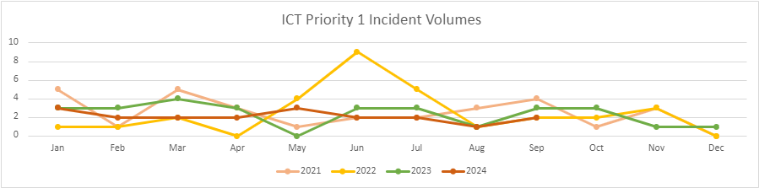
The following Priority 1 incidents were reported during the last period:
Date & Time | P1 Incident Summary | Affected Force | Business Impact & Action Taken | Root Cause & Learning | Time to Restore | Resolved
Force-wide
11/06/2024 19:19 | Network issues affecting TVP including ICT Service Desk and the 3 Contact Management sites. Applications affected include Avaya red telephony, CMP USD, CMP web, Outlook, Niche & the internet. | TVP | There was brief impact to remote connectivity services whilst the connectivity devices were restarted. LAN connections were available to ensure continuity. | VPN connectivity devices had restarted following environmental alerts (a water leak) within HQN datacentre. | 13mins | Yes
24/07/2024 07:06 | Control rooms were unable to access CMP, Telephony was unavailable for ICT, those working at Fountain Court on the HQ North site were unable to connect via either Gov wi-fi or the LAN, and this problem was experienced by some users at HQ South. | TVP | A number of users in various locations were unable to log on to systems including GOV-Wi-Fi, the LAN and the Avaya phones. This affected both staff in offices and working from home. A Silver review and debrief of this incident was undertaken by Criminal Justice and ICT teams, with a number of business continuity actions and learning taken away. CJ noted that had incident continued any longer there would have been an impact and potential loss of cases. | This incident was a result of an unplanned change applied by BT. This had not been approved by ICT and previously cancelled so the force was unaware. BT restored services to the primary circuit and ICT worked on the secondary circuit to restore resilience. | 2hrs 01mins | Yes
06/09/2024 07:07 | New users logging into internet based services received a Zscaler error message | Both | There was a brief impact to users connecting remotely for the first time. LAN connections were available for primary services to ensure continuity. | The root cause was identified as an unplanned effect of planned system maintenance by a third party | 13mins | Yes
23/09/2024 01:45 | PSN services were unavailable impacting systems including Livescan, VIPER and PNC | Both | This incident had an impact on operational areas of business including custody and the fingerprint bureau who had to resort to contingency measures. A full internal debrief has taken place with learning to be followed up. | Home Office connected systems were impacted. The cause was identified as a damaged PSN fibre cable in Bedfordshire. Resolution of the incident was delayed by Health & Safety issues in closing the road to allow the repair to take place with ICT taking steps to implement a workaround. | 5 hours to restore access to primary services, 49 hours to replace 1.5km of fibre cable | Yes
Contact Management
20/06/2024 11:49 | A number of 101 calls were intermittingly dropping out across both Forces | Both | 52 calls were impacted during this incident. None of the impacted calls were missed, or failed to re-connect. | Avaya and CMP services were restarted on affected Contact Management desktop devices due to a configuration conflict. | 1hr 46mins | Yes
18/07/2024 13:05 | Avaya was unavailable across all control rooms in TVP & HIOWC, which caused 999 and 101 calls to be queued as operators were unable to answer the calls. | Both | There was a brief impact to 101 contact response as the call queues were re-routed to prioritise 999 response. | The root cause was identified as from the primary Avaya server which had restarted. The failover did not apply as designed and was compounded by hunt groups not working effectively. | 1hr 30mins | Yes
23/08/2024 18:47 | Multiple ICCS terminals failed across Milton Keynes Contact Management Unit | TVP | The failure of these terminals has an impact on productivity for contact management staff, however contingencies and workarounds are already in place. | Related to known error caused by ‘Quality of Service’ configuration. ICT Silver Group have introduced controlled changes to avoid further issues. | 2hrs 13mins | Yes

Three of the five Priority 1 incidents recorded relate to third party services. JICT have specific vendor performance groups in place for telephony and related third party services to monitor and improve performance.

ICT P2 Incident Volume Trend: During the period 1 June 2024 – 30 September 2024, ICT recorded 31 P2 incidents.

P2 incidents are reported to allow assessment of any underlying trend or issue that might, if not addressed, lead to a business continuity incident. For the purposes of ICT incident reporting, a P2 incident is defined as “an ICT event which impacts on a single department or site, with a fix time required of less than 8 hours.”
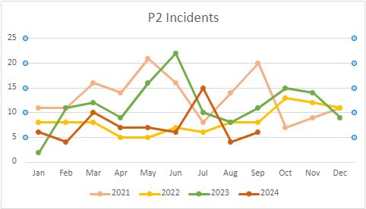

The July increase relates to issues with ICCS configuration and performance with improvements being introduced via Silver working group. A further 20% were due to unplanned third-party changes. The balance is within normal range.

Business Continuity activities
Strategic Governance Unit (SGU) continue to work with departments to update business continuity plans and remain focused on supporting SPOCs to undertake this properly, giving due consideration to the restructure within the Force Review. The team are looking at how they can further enhance and promote the Business Continuity strategy across the Force through improving awareness, building internal relationships, utilising learning from other Forces and with ongoing improvement and learning from incidents.
Cyber training sessions for Golds/Silvers have continued with a view to ensuring that all those staff in these key roles have been offered the chance to attend one of these sessions. Strategic Governance work to support ICT with the ongoing development of the force Cyber plan.
We continue to engage with regional and national BC counterparts, our colleagues in Hampshire and those within the Thames Valley Local Resilience Forum to share learning and to improve the Business Continuity framework within TVP.

OFFICERS’ APPROVAL

We have been consulted about the proposal and confirm that financial and legal advice have been taken into account in the preparation of this report. We are satisfied that this is an appropriate report to be submitted to the Joint Independent Audit Committee.

Chief Constable Date

Director of Finance Date

Appendix 1 – Risk and Issue Scoring Matrix

Appendix 2 – Risk Management Improvements Update
Several aspects have been mentioned in previous reports, including the setting of explicit risk appetites and tolerances. The aim here is help Risk Owners more robustly manage their risks and for CCMT and JIAC to exercise more effective oversight.
This appendix provides an outline of our thinking and its possible application to two worked examples: SR 98 (Custody); and SR 122 (Policy Management).
Put simply, risk appetite is the amount of risk that an organisation is willing to take to achieve its objectives and risk tolerances are set to enable the organisation to assess how it is performing against that appetite. A simple approach is to define “Red, Amber, and Green” zones for such tolerances – the Green zone represents operation (recent and forecast) within the risk appetite, the Red zone represents substantially exceeding the risk appetite, and the Amber zone is in between. When one is in the Red zone, the risk has usually crystallised into becoming an issue, but in any case, the need for urgent and robust remediation is necessary. When one is in the Amber zone, the risk still needs attention (for matters under one’s control) and the trend must be clear to ensure regression to the Red zone is averted where possible.
There are established and developing approaches to defining risk appetite levels (the Government promoted so-called Orange Book and the ongoing work of the NPCC’s National Risk Management Forum). It is expected that we will propose and adopt the following definitions:
- Averse (a zero appetite for taking risks)
- Minimal (risks can be taken in limited or low scale circumstances)
- Cautious (tendency to stick to the status quo but with considered risk-taking)
- Open (innovation is supported, receptive to taking risks where perceived benefits outweigh costs)
- Eager (strong focus on innovation and willingness to accept failures on occasion)
We will propose the following risk types (taken largely from the Orange Book):
- Governance & Strategy
- People
- Operations & Service Delivery
- Justice
- Legal
- Estates
- Financial
- Security
- Business Change
- Reputational
- ICT/Technology
- Health & Safety

We will apply these risk types within each Strategic Risk in the risk register record and assessment procedure (so for example, a business risk for which multiple risk types are relevant will have a composite risk appetite, whereas a business risk with only a single relevant risk type with have that risk appetite.
As part of our advancement of the risk management framework in the force and the benefit of applying tolerances to some of our most ‘problematic’ strategic risks, we initially looked at attrition as the current highest scoring risk on the strategic risk register. Key control measures within attrition were provisionally identified to tease out different tolerance ranges (for example, student officers, probationers and other staff groups).
Alongside this, People Directorate are currently undertaking of a proposed overhaul of their current risks; having found that most of their risks share common causes and indeed are often causes or consequences of each other. People Directorate are proposing a more thematic, overarching approach. This work is yet to be finalised and agreed by CCMT but as a result, whilst acknowledging that setting and using tolerance levels within our People risks is a valid and useful tool, the work around attrition, and expanding tolerance levels into the other People owned risks, has paused to allow the People Directorate strategic risks to be formalised and adopted onto the strategic risk register – the aim is for a comprehensive update to be provided in the coming months.
The two examples that follow show how we propose to include pictorially additional insights into risk appetite and tolerance – this is work in progress, but we think it may be informative to expose the evolving ideas to JIAC at this time.
Finally, we plan to support occasional ‘deep dives’ into long-standing Strategic Risks. We have drafted a template to support such an exercise. This is included at the end of this document

The Corporate Governance Officer team, December 2024
SR 122 | There is a risk that officers and staff act in a way that does not comply with laws/regulations/policing standards/organisational policies due to a large proportion of Force policies being out of date. There is an additional risk that EIAs are not current / reviewed, in line with our obligations under the Public Sector Duty, and that some of our policies held on the external website are not current. |  |  |  |  |  | Risk owner: | DCC Ben Snuggs
SR 122 |  |  |  |  |  |  | Risk Lead: | Alison Nicholls
SR 122 |  |  |  |  |  |  | Risk Type: | Governance & Strategy
Impact: | 2 |  | Likelihood: | 3 |  |  | Risk score: | 6
Risk Action: | TREAT | Date raised | Feb 2024 | Review date: |  | Nov 2024 | Next review date: | Feb 2025
Consequences: |  |  |  |  | Causes:
Not fully quantifiable, but could be that officer and staff are following incorrect/out-of-date procedures and standards and there is insufficient awareness of policies generally and changes in particular.  Some policies do not include evidence of an EIA being conducted, or, where a template has been completed but has not been reviewed and is potentially out of date. This means we have not complied with our obligations under the Public Sector Equality Duty which could result in actions taken against us and reputational damage. |  |  |  |  | - TVP does not review and refresh the policy sufficiently (including deleting a policy or converting it to guidance when appropriate to do so)  - TVP does not make officers and staff sufficiently aware of policies and changes when these arise  - Officers and staff don’t read and understand policies and line managers don’t ensure that their direct reports are aware and understand  - Officers and staff don’t comply in practice, even when aware of policies, be this wilfully or negligently  - During the pandemic SGU has lost a policy volunteer  - Lack of capacity in the SGU to lead on policy management  - Ownership of policies lies with departments across the Force, which is not fully understood  - Officers and staff may not be aware of their obligations under the Public Sector Equality Duty re conducting an EIA.

Risk and Control Assessment
Risk Appetite: TVP has a moderate risk appetite for operational and organisational policies being out-of-date.

All policies have a stated review and refresh cycle (typically annual or biennial) and, in addition, a Risk Owner and Lead should review and revise a policy whenever there is substantive change at any time (for example if regulations change or TVP’s internal policy changes). We have chosen to take a simple approach initially and measure how TVP is doing against its appetite by considering the timeliness of regular refreshes, where tolerance levels can be expressed in terms of the proportion of policy documents that are current (i.e. within their review cycle). We have illustrated 70% as being where we want to be, in line with the risk appetite (i.e. the Green zone) and 30% or lower as where we definitely do not want to be (i.e. the Red zone).

The latest assessment is that 51% of policy documents are current, placing the measure in the Amber zone, as shown below.

key factor | risk and control measures | tolerance levels | example assessment | observations
Provision of reviewed policies adequacy | Policies which are current and reviewed in line with agreed policy lifecycle | G = < 70%  R = > 30%  Completed and in-date policies currently 51% | 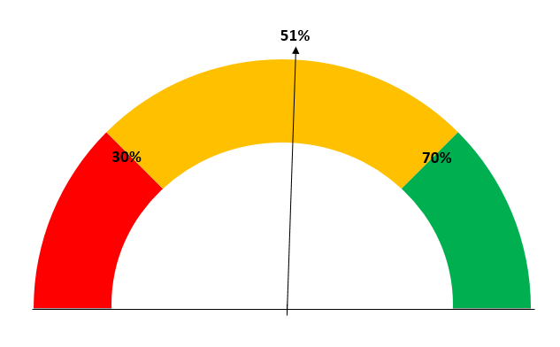 | Increased from previous score of 41% policies being current

SR 98: | There is an ongoing risk that TVP is not able to provide a Custody service to safely meet Force demand. |  |  |  |  |  |  | Risk owner: | T/ACC Wright  D/C/Supt Garside
SR 98: |  |  |  |  |  |  |  | Risk lead: | Supt Mason
SR 98: |  |  |  |  |  |  |  | Risk type: | Operations, Justice
Impact: | 3 |  |  | Likelihood: | 3 |  |  | Risk score: | 9
Risk Action: | TREAT |  | Date raised: | Feb 2021 | Review date: |  | Nov 2024 | Next review date: | Feb 2025
Risk cause: |  |  |  |  |  | Consequences:
- Resourcing of Sergeants and Detention Officers in Custody (local risk 140)  - Mountain Healthcare resourcing (local risk 163)  - Custody Estate failures – e.g. heating, cooling, water (local risk 201)  - Custody cell checking (local risk 182)  - Custody healthcare re-procurement (local risk 205) |  |  |  |  |  | - Unable to meet the Force’s commitments and Operational Priority Outcomes 2020/21.  - Custody relying on abstracting significant numbers of PCDOs from our already overstretched ICR teams to cover the shortfalls.  - The overuse of PCDOs with limited training is placing additional pressure on the custody officers and full time DOs to supervise and support them  - Welfare concerns for officers who are working longer hours (e.g. increased referrals to OHU due to stress and fatigued officers);  - Increased workload and responsibility for officers on duty as they are under resourced and dealing with a higher volume of arrests;  - Reduction in the number of Sgts and DO wanting overtime to cover shifts;  - ICR transporting detainees further distances to available Custody suites.  - Closure of suites due to insufficient DOs – displacement of demand on to fewer number of staff risks increasing further staff attrition

Risk and Control Assessment
Risk Appetite: TVP has a low risk appetite for having insufficient Custody capacity at any time.

Custody capacity has several dimensions – the number of cells, the number of Detention Officers and Custody Sergeants, and Healthcare capacity being principal ones. This risk is an example of a chronic risk (i.e. it is always exists with the CJ/Custody Command as a fundamental consequence of TVP’s role and business processes) that has been included as a Strategic Risk for several years because the risk of actual capacity being lower than required has been very high and has merited additional scrutiny by CCMT and JIAC.

The Custody Strategy Group reviews a set of management reports and information on a regular basis. We have taken some 14 constituent factors and considered possible Red/Amber/Green tolerances (with the same interpretation as explained for SR 122 above). Some are still ideas and have yet to be confirmed and worked through. That is:
  - A risk appearing in the Red zone means we are in a place that is not tolerable and the risk must be brought back within the Amber/Green zones.
  - A risk appearing in the Green zone means we are satisfied that we are in the desired place.
  - A risk in the Amber zone means while we are not in the desired place, we can tolerate the situation (unlike in the Red zone) but would want to bring the risk back to the Green zone
Whereas, for the SR 122 example we only presented one risk and control measure, for this SR 98 example, we have multiple components and propose to derive an overall risk and control rating as follows:
  - Red if there are 2 or more constituent Red ratings
  - Green if there are no constituent Reds and 10 or more constituent Greens
  - Amber for anything else.
In this example, looking at the information presented, there are 3 assessed Greens, 7 assessed Ambers, and 1 assessed Red. So the overall assessment for SR 98 is Amber.

key factor | risk and control measures | tolerance levels | example assessment | observations
Resourcing adequacy | Detention Officers at period end – FTE (? or available to deploy) vs budget/establishment | G = > 95%  R = < 85% | 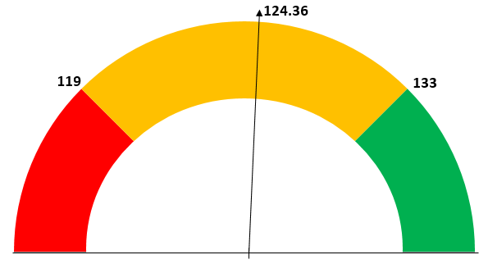
 | Custody Sergeants at period end – FTE (? or available to deploy) vs budget/establishment | G = > 95%  R = < 85% | 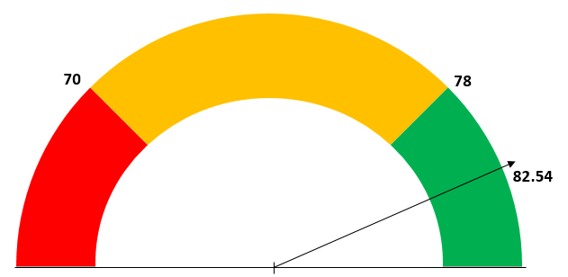
 | Training completion as at period end vs deadlines | G = > 95%  R = < 90% | 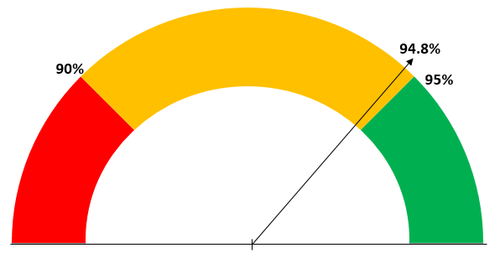
Demand vs expectation | Attendances for the period vs expected | G = < 105%  R = > 115% | 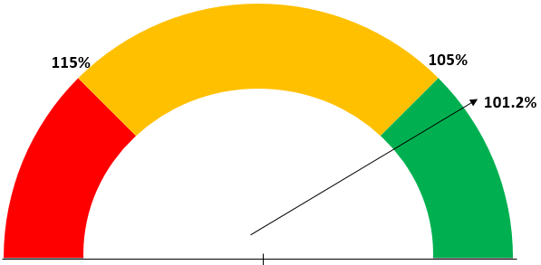
Healthcare adequacy | Detained Persons referred vs arrested (Primary referrals) | G = > 70%  R = < 30% | 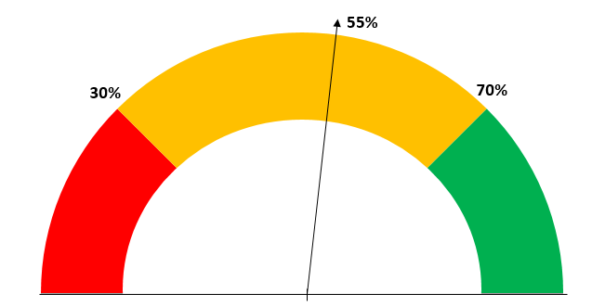
 | Healthcare interactions, cases vs all attendances for the period where healthcare delays more than 60 minutes | G = < 5%  R = > 10% | 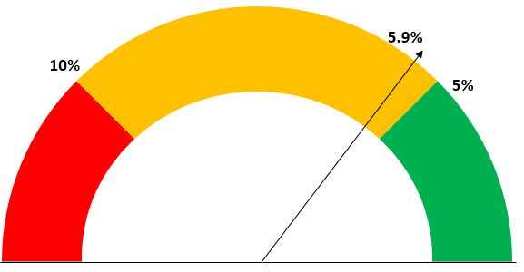
 | Healthcare resources/resilience | To be developed | to be developed
Outcomes vs Standards/Targets | Custody closures, cells x days closed total for the period | G = < 20  R = > 60 | 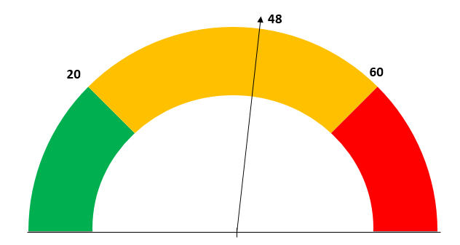
 | Custody Record Peer Reviews 98 factors are scored and RAG-rated) | G = > 4 greens and no reds  R = > 4 reds | 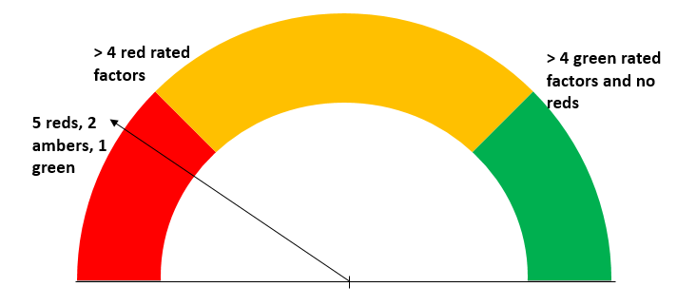
 | Appropriate Adults, average time to attend for the period | G = < 120 mins  R = > 180 mins | 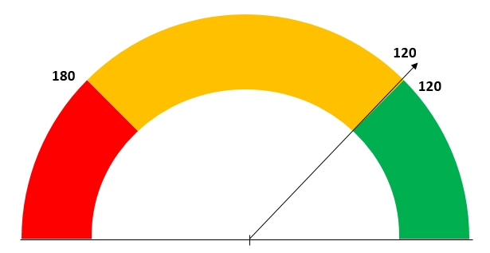
 | Adult Strip Search (Exposing Intimate Parts), number of cases with concerns during the period | G = none  R = > 1 | To be developed
 | Child Strip Search (Exposing intimate Parts), number of cases with concerns during the period | G = none  R = > 1 | 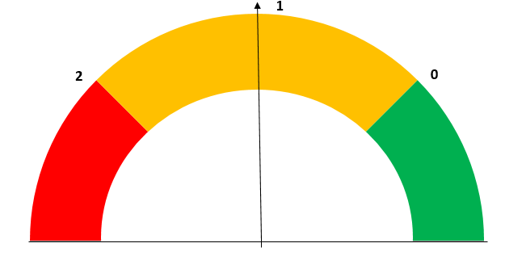
Estate Failures (Heating, Cooling, Water/Sewage, Infestation) | cells x days impacted total for the period | To be developed | To be developed
 | Incidents, number during the period | G = 1  R = > 2



